Cost analysis of generating roi

# abstract

In this document, we explore the formula which generates ROI (return of investment). The paper is not a detailed financial analysis of project economics. However, they do provide simple, clear metrics based on up-to-date and reliable information which can be used to evaluate the cost and performance of different renewable power generation technologies. This report helps to inform the current renewable power generation and assist potential investor make informed decisions on investment.

This report is consisted of main factors which affect ROI and the main formula.

# discussion

Discussion part is consisted of main factor which affects overall ROI and discussion of cost which is between wind power and solar power.

## Main factor

### civil works and construction fee

The construction costs include transportation and installation of wind turbine and tower, the construction of the wind turbine foundation (tower), and the construction of access roads and other related infrastructure required for the wind farm.

For the turbine, the largest costs components are the rotor blades, the tower and the gearbox. Together, these three items account for around 50% to 60% of the turbine cost. The generator, transformer and power converter account for about 13% of the turbine costs, with the balance of “other” costs being made up miscellaneous costs associated with the tower, such as the rotor hub, cabling and rotor shaft. Overall, the turbine accounts for between 64% to as much as 84% of the total installed costs, with the grid connection, civil works and other costs accounting for the rest.

For the solar panel, the largest costs come with the inverter. All solar systems come with an inverter that converts DC to AC and because it is the working part of the system it is the component most likely to break. For this reason, Solara only supplies the top handful of brands from companies like Fronius, Enphase and SolarEdge. A cheap inverter from China may cost $500 compared to $2000 for a European Made equivalent.

### Operations and maintenance costs (O&M)

The Operation and Maintenance (O&M) cost of a Component is the cost associated with operating and maintaining that Component. The total O&M cost of the system is the sum of the O&M costs of each system Component.

### supply chain cost, sales tax on equipment and other cost

Total supply chain management cost is the sum of the costs associated with the processes to Plan, Source, Deliver, and Return and is calculated as Sales - Profits - Cost to Serve (e.g., marketing, selling, administrative).

## Formula for generating roi

**ROI** = Net Profit / Total Investment * 100

Net Profit =(( energy power * electricity price) - maintenance fee) * number of year

Investment = installation cost

(Note: if possible, please take inspection fee and technology renew fee,the price of conducted material, labour cost in consideration)

### wind energy

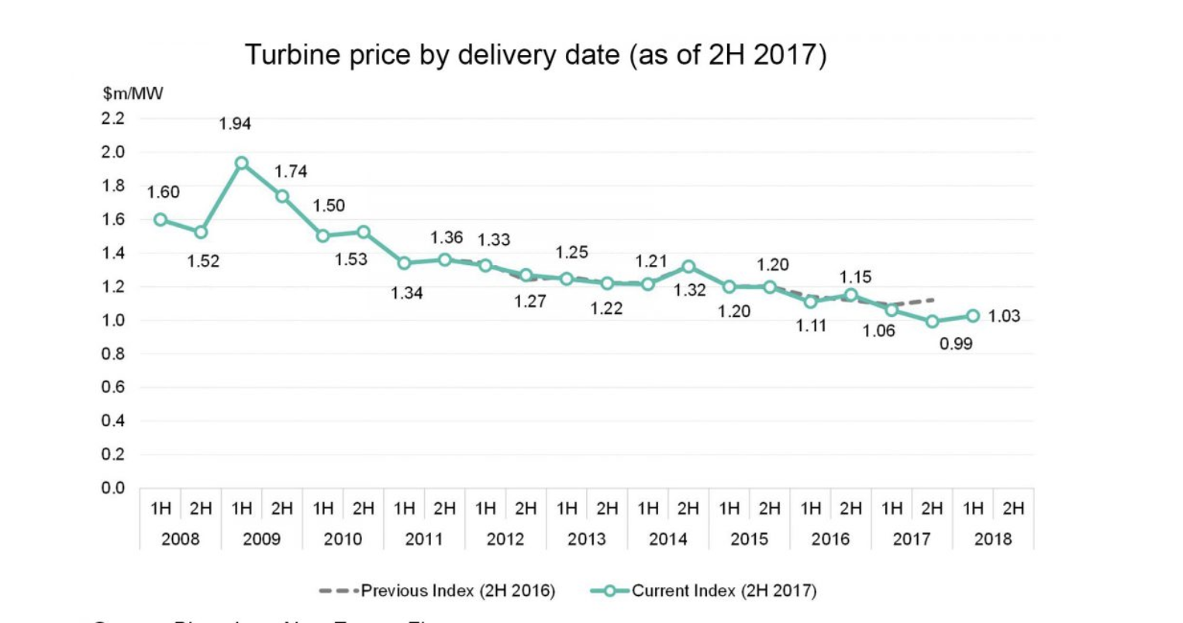

The costs for a utility scale wind turbine range from about $1.3 million to $2.2 million per MW of nameplate capacity installed. Most of the commercial-scale turbines installed today are 2 MW in size and cost roughly $3-$4 million installed.

So, 10000 is selected as average **installation cost over area.**

The median operations **and** maintenance (O&M) cost **for** a U.S. utility-scale **wind** farm with a full **wrap** guarantee was just over $48,000/MW in 2016

Thus, **maintenance cost** = 48000/MW * 2MW= $96000/year

maintenance cost rate = 96000/area input=48.89/year

(installation cost = 3.5 million usd; maintenance cost = 96000/year)

Annual profit = **0.5kWh/m^2(input)** * **r^2*3.14 (area input)** * 0.23 dollar/kWh * 24h/day * 365 day/year

Net profit = (annual profit - maintenance cost rate * area input) * number of year - installation cost * area input

ROI = Net profit / (installation cost * area input) * 100

### Solar energy

The average price per watt for solar panels ranges from $2.67 to $3.43, and solar panel costs for an average-sized installation in the U.S. usually range from $11,214 to $14,406 after solar tax credits.

So installation fee gets the average of $12810

**Maintenance cost:**

$150 per year

ROI for solar energy/m^2 = return/investment

= (((**energy/ m^2 (input)**\*365*23.03)\***area size(input)** - maintenance fee * **area size(input)) \*** number of year -12810) / $12810

Annual profit = **energy/ m^2 (input)**\*365*23.03)\***area size(input)** **\*** number of year

Net profit = (((**energy/ m^2 (input)**\*365*23.03)\***area size(input)** - maintenance fee * **area size(input)) \*** number of year -12810)

ROI = Net profit / 12810

# conclusion

Overall, through the formula we compute we could determine the ROI according to solar energy and wind energy.

Reference:

<https://about.bnef.com/blog/2h-2017-wind-turbine-price-index/>

<https://www.irena.org/documentdownloads/publications/re_technologies_cost_analysis-wind_power.pdf>

<http://www.windustry.org/how_much_do_wind_turbines_cost>

[**https://news.energysage.com/how-much-does-the-average-solar-panel-installation-cost-in-the-u-s/**](https://news.energysage.com/how-much-does-the-average-solar-panel-installation-cost-in-the-u-s/)

<https://reneweconomy.com.au/hidden-cost-of-rooftop-solar-who-should-pay-for-maintenance-99200/>

<https://www.irena.org/-/media/Files/IRENA/Agency/Publication/2018/Jan/IRENA_2017_Power_Costs_2018.pdf>